Practical - 9
Practical Title: Secure User Registration with Database Insert, Duplicate Email Check, and Password Hashing
Problem Definition : Implement secure user registration by inserting user details into MySQL using MYSQLi. Validate input on frontend and backend, check duplicate email/username, hash passwords using password_hash(), and display appropriate messages.
- Is password_hash() used before storing passwords?
Answer: Yes. The plain-text password is never stored. Before the INSERT query, the password is hashed with password_hash($password, PASSWORD_DEFAULT), which uses a strong algorithm (bcrypt) with an automatic salt. Only the hash is saved in the database. Because hashing is one-way, even someone with database access cannot read the original passwords, and they can be checked later with password_verify().
- Is duplicate email/username checked?
Answer: Yes. Before inserting, the script runs a SELECT query on the email (and username) to see if it already exists. If a row is found, registration stops and the message “Email already registered” is displayed. I also added a UNIQUE constraint on the email column in the database as a second safeguard against duplicates.
- Are frontend and backend validations consistent?
Answer: Yes. The same rules (required fields, name format, valid email, 10-digit mobile number, minimum password length and strength, password match) are applied in JavaScript on the client and again in PHP on the server. Frontend validation gives instant feedback to the user, but it can be bypassed, so the backend validation is the one that actually protects the database. Keeping both consistent avoids confusing situations where the form accepts data the server rejects.

C. Evidence of Work (Screenshots)

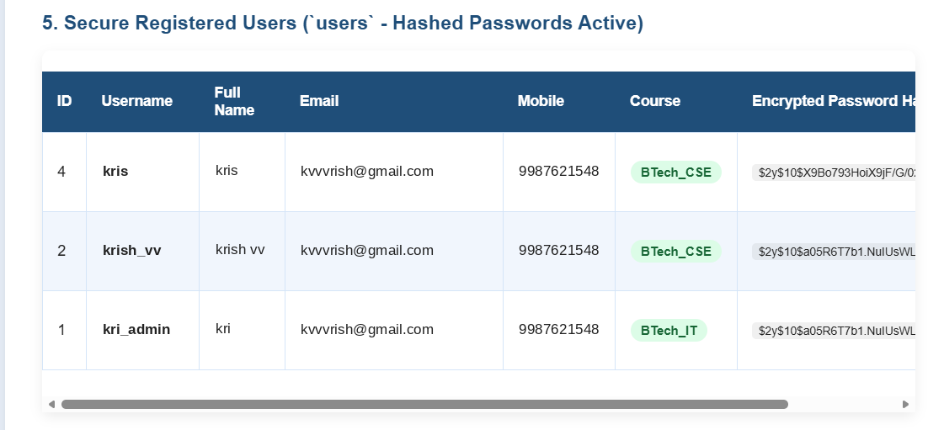

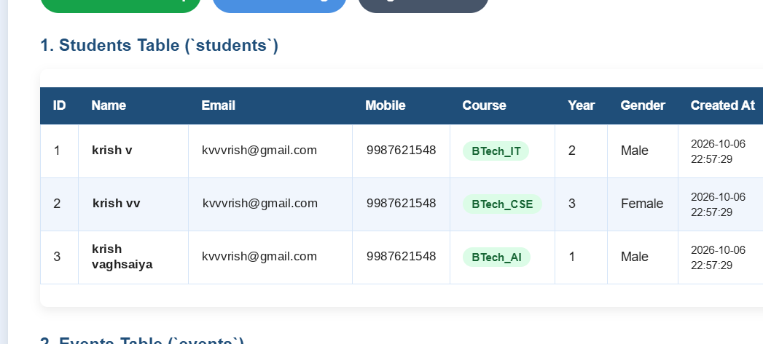

D. GitHub Repository Link :

https://github.com/kvvaghasiya49/Web_Development.git

E. Challenges Faced:
- Keeping the JavaScript regular expressions and PHP validation rules identical so the results matched.
- Handling the duplicate-email case cleanly without showing technical database errors.
- Understanding that password hashes are long and the password column needs enough length (for example VARCHAR(255)).

F. Learning Outcomes:
- I can implement a secure registration module that inserts user data into MySQL using MySQLi.
- I understand why passwords must be hashed and how password_hash() works.
- I can detect duplicate records using SELECT checks and UNIQUE constraints.

G. Faculty Remarks:

